Name:  
Group:  
Date:

# A. WARMER

1. 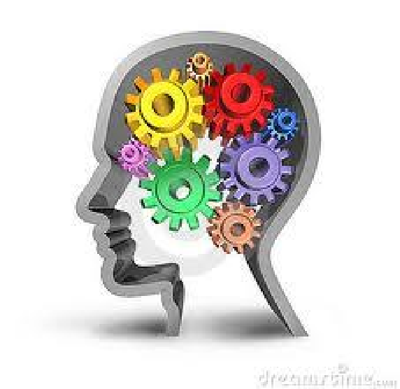How would you define intelligence?
2. How do we currently measure intelligence?
3. How do you think we should measure intelligence?
4. Where do we get our intelligence from?

# B. TEST YOUR INTELLIGENCE

Go tot he website: <http://www.free-iqtest.net>..  
Answer the 20 questions and write down the endresult: I have a score of IQ ………..

# C. VOCABULARY

Match the words on the left with the words on the right to form commonly used collocations or phrasal verbs.

1. Dog a. off
2. round b. murder
3. took c. aware
4. committing d. insane
5. Fully e. of applause
6. Totally f. barking
7. Bars g. of soap

Match the word on the left with the definition on the right:

|  |  |
| --- | --- |
| 1. level playing field a. | to become more exciting |
| 2. prop b. | to be at a loss, unable to find the solution |
| 3. implement c. | a fair competition where all parties have equal advantage |
| 4. to be stumped d. | to experience ongoing success |
| 5. hotting up e. | an item used to assist during a theatre production |
| 6. on a roll f. a tool or instrument | |

1

STUDENTS’ NOTES

# D. INTRODUCTION TO LISTENING

Watch the clip: Defining intelligence.

Answer these questions:

1. How does Spearman define ‘ intelligence?
2. How does Gardner define ‘intelligence’?”
3. What is the difference between the two theories of intelligence?
4. Which one is more appealing to you?

# 